**GIT**

**GITLAB-https://gitlab.com/pranesheswaran2005-group/gitdemo**

**Question-1(Git lab configuration using Git bash)**

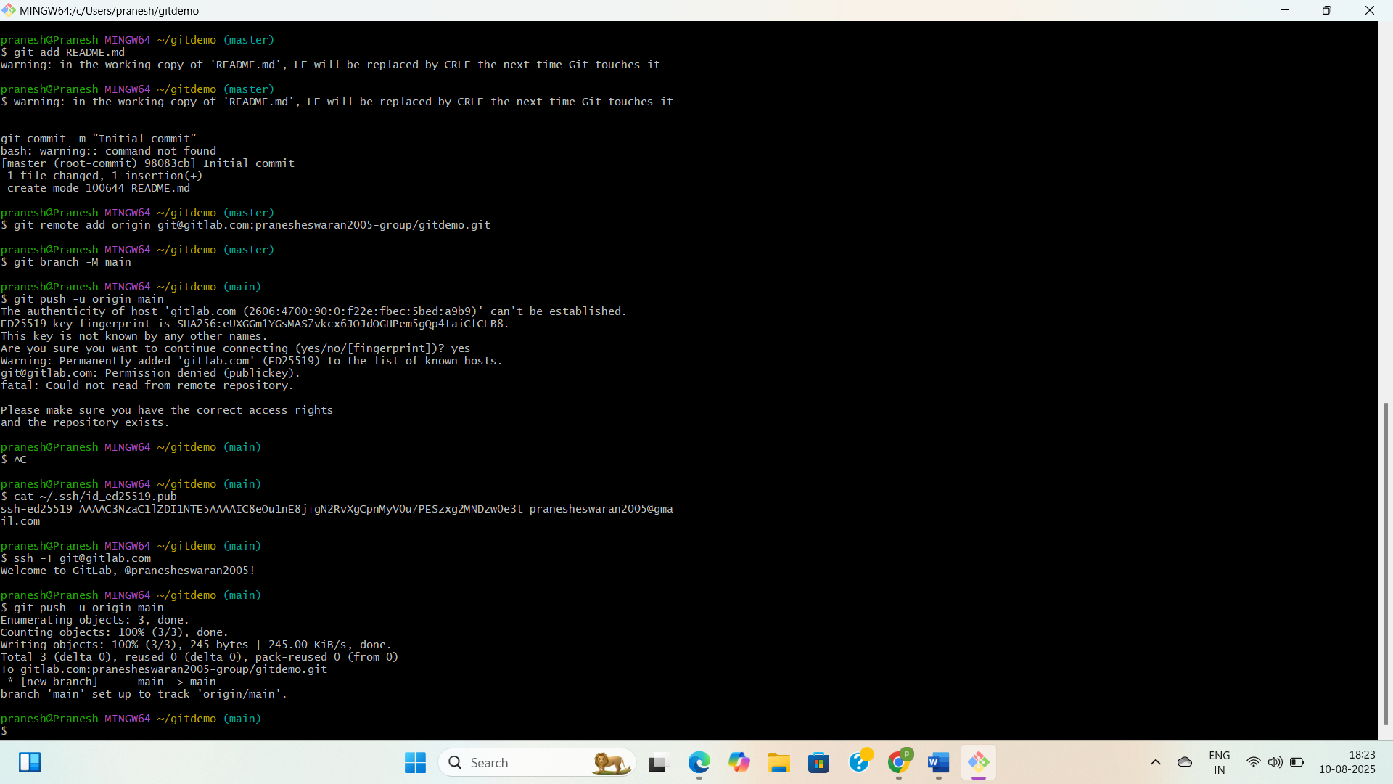

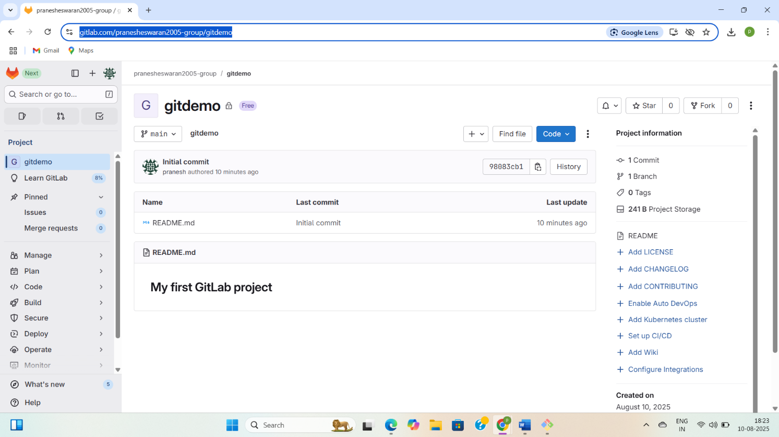

**2.Question-2(Create a “.log” file and a log folder in the working directory of Git)**

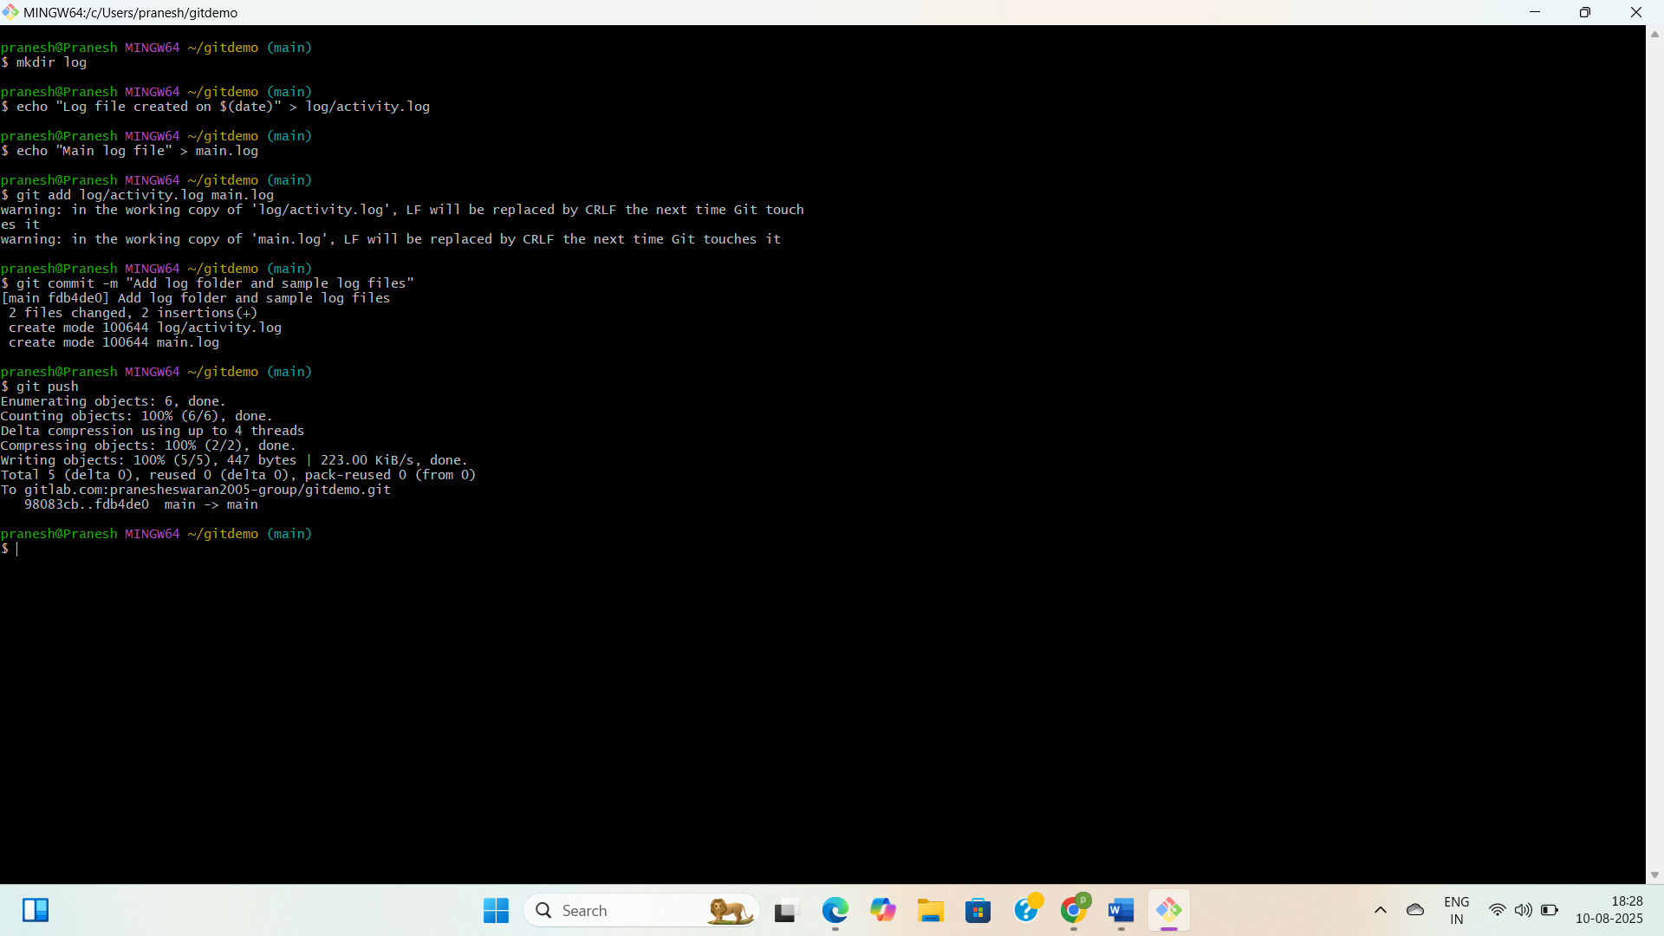

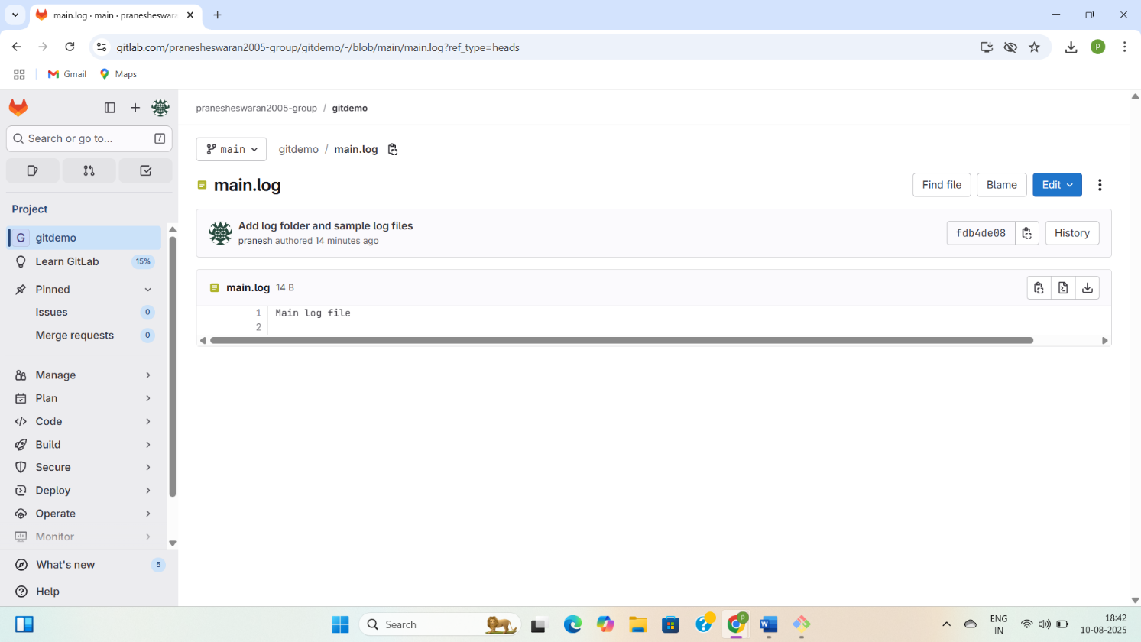

**Question-3(Git Branching and Merging)**

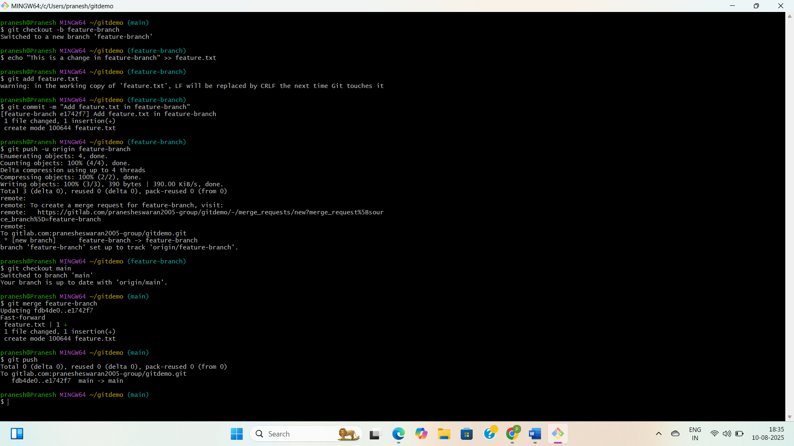

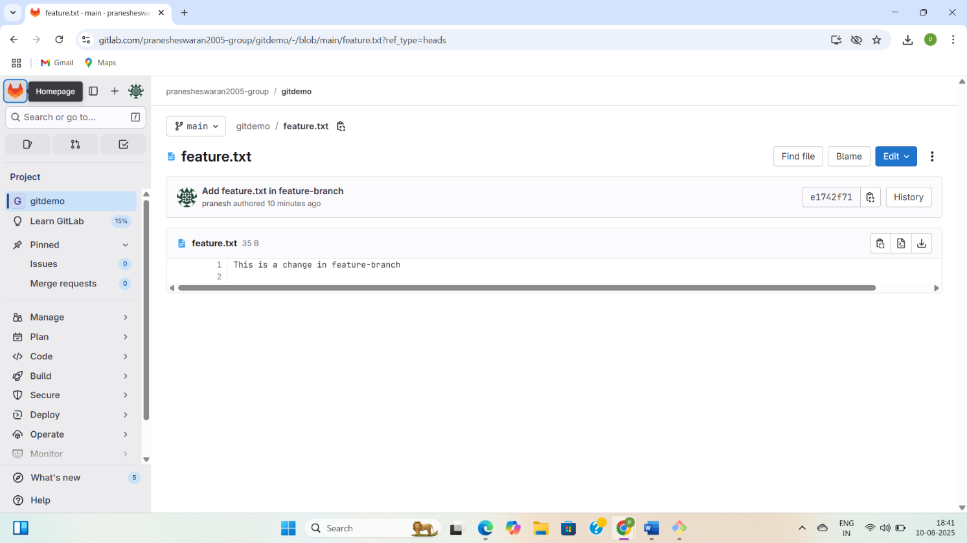

**Question-4(Implement conflict resolution when multiple users are updating the trunk (or master))**

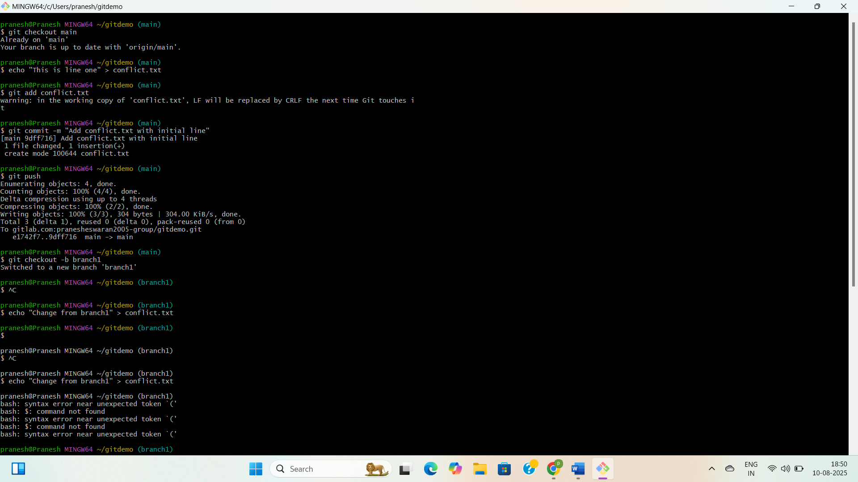

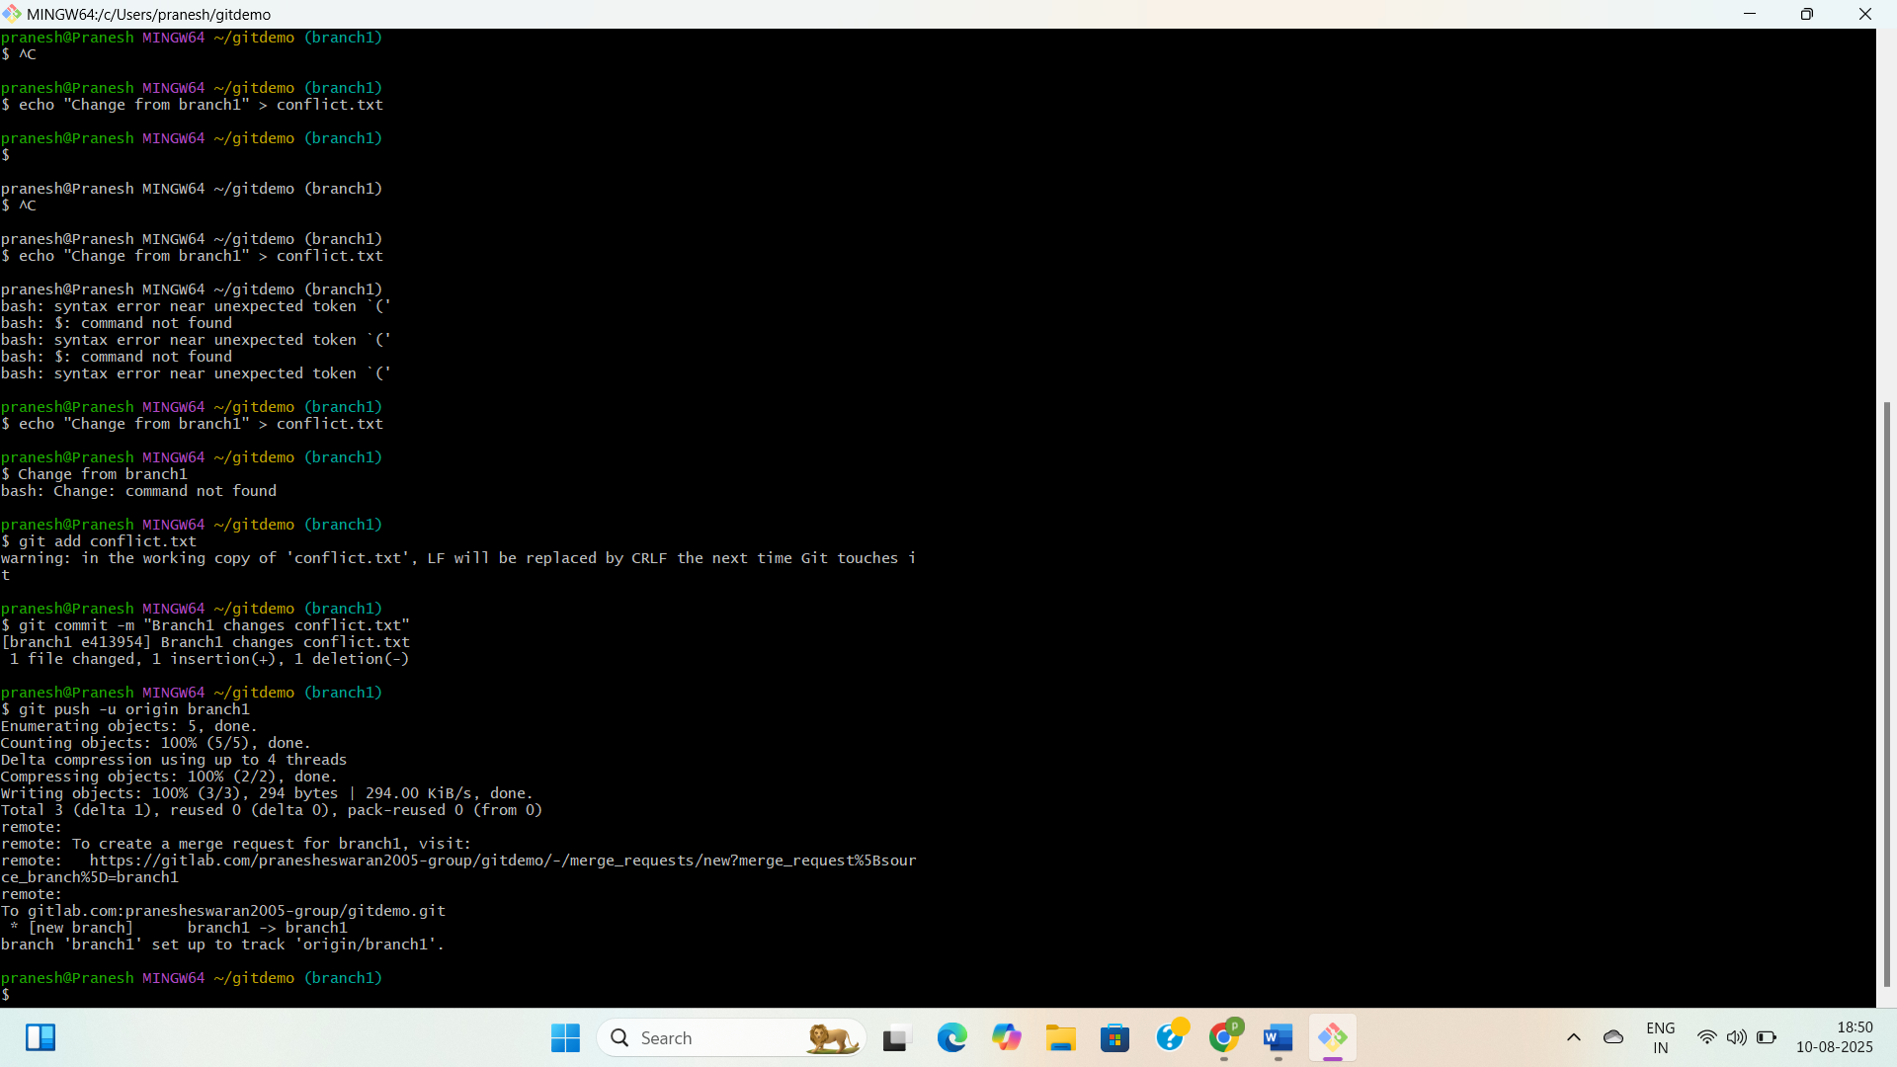

**Question-5(Execute steps involving clean up and push back to remote Git)**

Befor deleting I will have branch 3 in branches

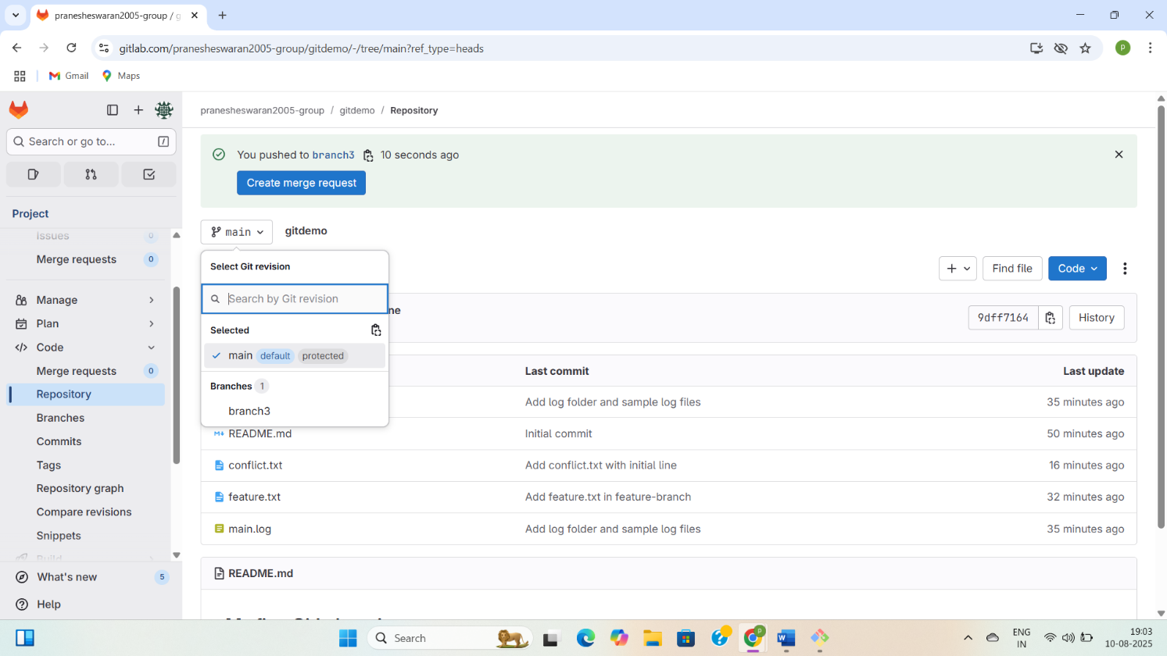

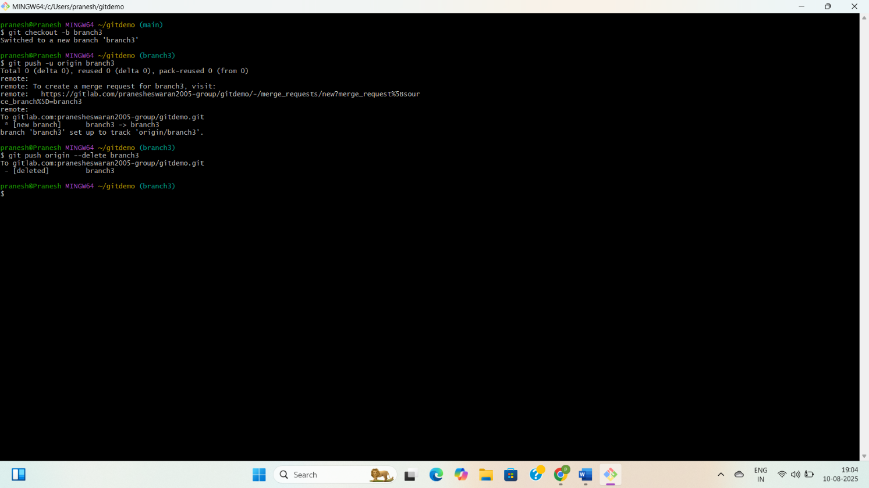

After deleting the branch 3

